Linux as kernal not OS.

1983, GNU ("GNU's not Unix")
full form

=> Started by RICHARD STALLMAN.

GNU => Open Source OS.
|
---> Combines with (Linux – kernal)
|
=> OS

By 1992 completed major os but kernal, GNU Hurd are not completed.

Linux Torualds in (1991) started the process found in (1992) the Version = 0.12. Name as LINUX bcoz of it is name of discover.

Linux - Monolithic kernel
|----------------------------------------------|
|
User mode - Kernal mode – Hardware. |
|------------------------------> It is Kernal based os.

Microkernel based OS.

⇒ kept separately (user & kernal)

Working of Linux

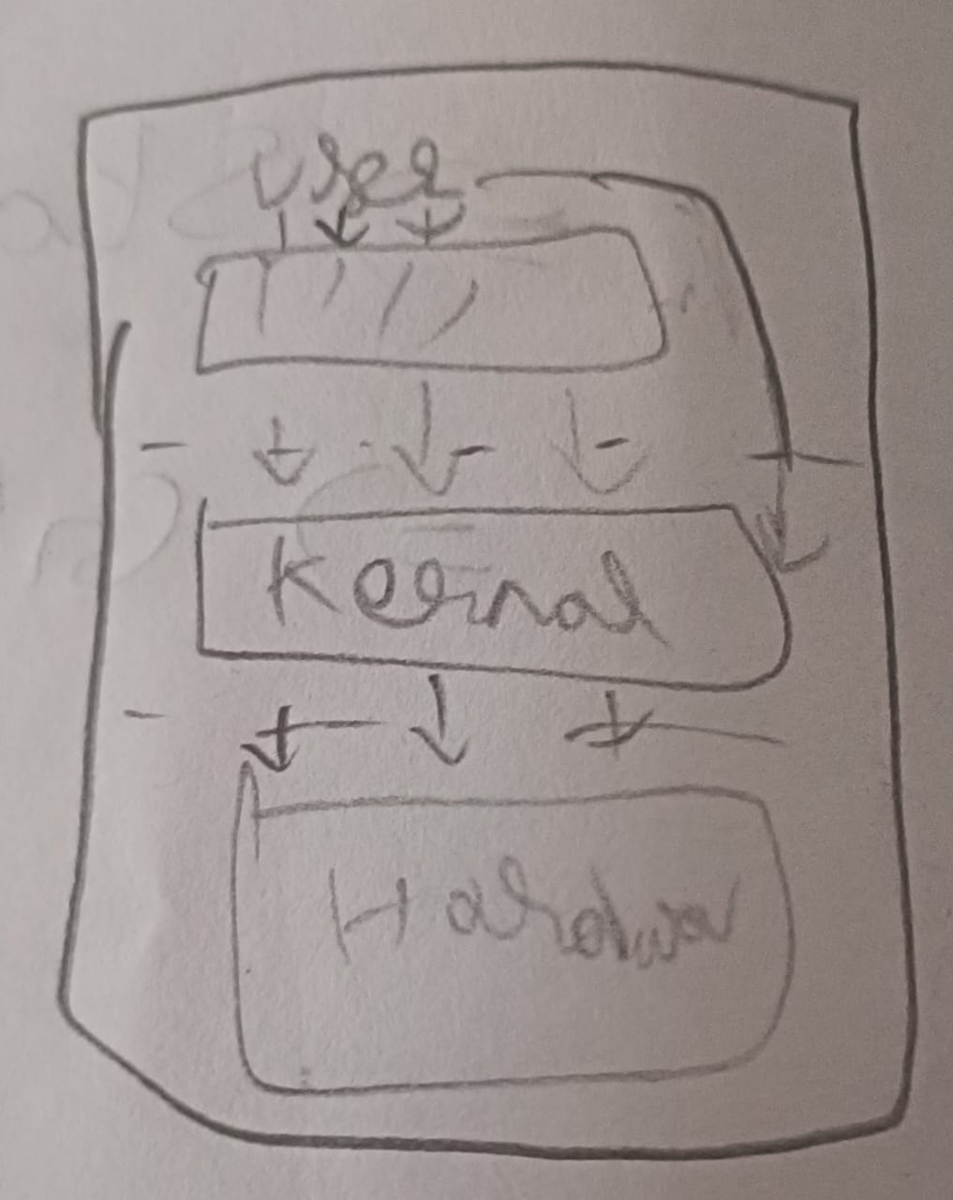

Code
(or)
User (->) Program -> Kernal mode -> Hardware

User (->) Program -> System Call Interfaces.

User (->) Program -> System library -> System Call Interfaces.

If we use library function so we use system library.

Linux shell commands

* Internal (or) Built in Command.
* External commond.

(two type)

Home <= ~ $ => you don't have access to root
[sudo su = root] -> seperated command
Path (, other any)

Relative , Absolute are two types.

Relative:

:~$ CD./D1/D2/D3
|
|-----> Current directory

:~/d1$ CD../d1/d2/d3
|
|-------> comes out of directory

(./../current to destination)

Absolute:

soure file or file
|
(from boot to destination)

Eg: Cd/home/dir/d1/d2/d3

Mkdir = to make dir.

cd -> to come into the dir.

cd. -> current directory.

cd.. -> Comes out of the directory.

relative, absolute
Sudo apt-get install tree ---------|
|
|
To create files |
|
tree > tree_files <-------------------|
(folder nome)

Vim tree_files

ls => list

- l=

-ls=

-lai =
(inode)

rm = remove

rm_rf = recurrsive forcefully.

Inode => for one file.

It is created for all files separately.
|
Inode

To view tree : Cd directory tree
|
->To view the directory & file in the formet.

ls, ai, Cd, etc.. = Internal Command

Enviromental Variable = External commond

“which” =commands

Eg:

which cd ,which ls = both are different C working command.

man man = alot manpage.

mon hier = filesyetem hierarchy ( Description)

Sudo = to access files by create us as fake Id (User) like a real user.
we access the files us as fake Id.

